Dr. Prasenjit Mandal
Scientific Advisor, Department of Technical Sciences, Algebra Bernays University, Croatia
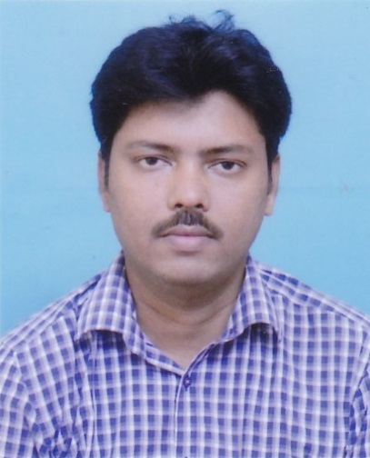

Dr. Prasenjit Mandal is a researcher of Mathematics and teacher at Bhalukdungri Jr. High School, Raigara, Purulia, West Bengal, India. He also serves as Scientific Advisor in the Department of Technical Sciences at Algebra Bernays University, Zagreb, Croatia, and has a research affiliation with the Research Center of Performance and Productivity Analysis at Istinye University, Turkiye. He earned a B.Sc. (Honours) in Mathematics from Vidyasagar University, an M.Sc. in Mathematics from Guru Ghasidas Central University, and a Ph.D. from Vidyasagar University. His research connects group decision-making, soft computing, applied artificial intelligence, rough sets, fuzzy algebra, linguistic Z-numbers, three-way decisions and social-network-based decision systems. His publication record includes 17 papers in SCI/SCIE-indexed journals, three papers in Scopus-indexed journals and 10 papers in UGC CARE-listed journals. Dr. Mandal is a co-author of Quantum Theory, Decision Making and Social Dynamics, published by Elsevier/Academic Press, and has developed decision models for healthcare, renewable energy, sustainable supplier selection, logistics and human-AI collaboration. His work is recognized in the AD Scientific Index - World Scientists Rankings and emphasizes transparent mathematical methods for complex decisions under uncertainty.
Research focus: Group Decision-Making | Rough Sets | Fuzzy Systems | Linguistic Z-Numbers | Applied AI
Google Scholar | ORCID | ResearchGate | Email

